**Sample input – output**

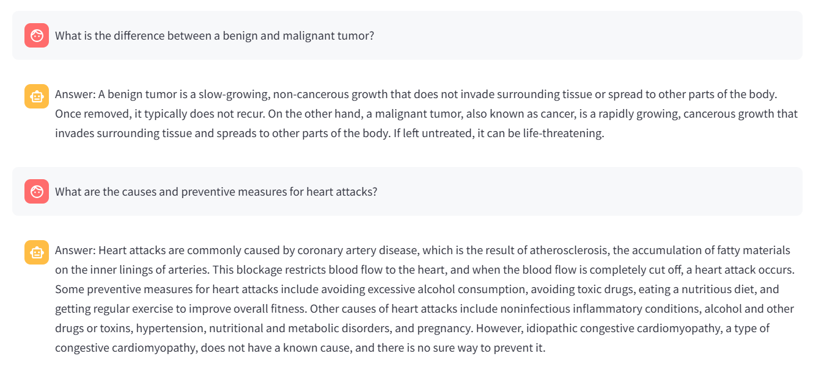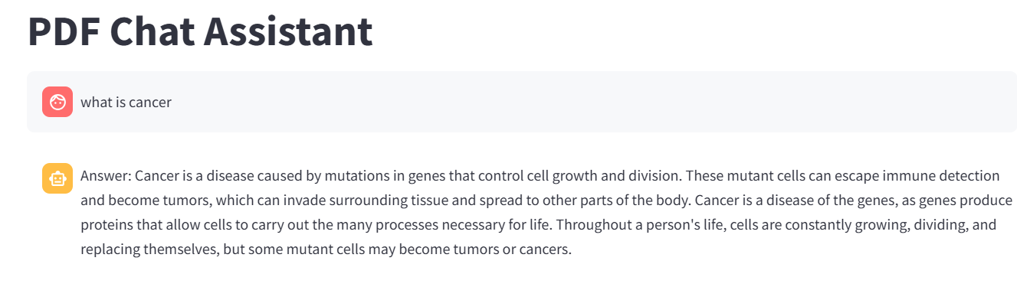**PDF Used-** The_GALE_ENCYCLOPEDIA_of_MEDICINE_SECOND.pd

